**URL Shortner App**

Student :- Saurabh Hundare

**Under the Guidance of**

**Mr. Kanav Bansal**

|  |  |
| --- | --- |
| Table of Content | Page No. |
| Abstarct | 3 |
| Introduction | 4 |
| Flowchart | 4 |
| Output | 5 |
| Technology | 5 |
| Conclusion | 6 |
| References | 6 |

**Abstarct**

The URL Shortener Flask app is a web application that allows users to shorten long URLs into short, easy-to-remember links. The app is built using the Flask framework and the SQLAlchemy library to create a database that stores the long and short URLs.Here I have Created a Flask app that takes the long urls of the User and give a short Urls that can be used by the user in order to visit that link.

The app has three main views: the homepage, the URL shortening endpoint, and the redirect endpoint. The homepage provides users with a form to submit a long URL to be shortened. The URL shortening endpoint takes the long URL and generates a random short URL, which is then stored in the database. The redirect endpoint is used to redirect users from the short URL to the corresponding long URL in the database.

**Introduction**

The URL shortener Flask app is a web application that allows users to shorten long URLs into short, easy-to-remember links. This report provides an overview of the app's functionality, architecture, and implementation. In this project a user can make his long url in short url by pasting the url in the input given. He/She can also revisit the url by seeing it in the table given below as it is stored in the database.

**Flowchart**

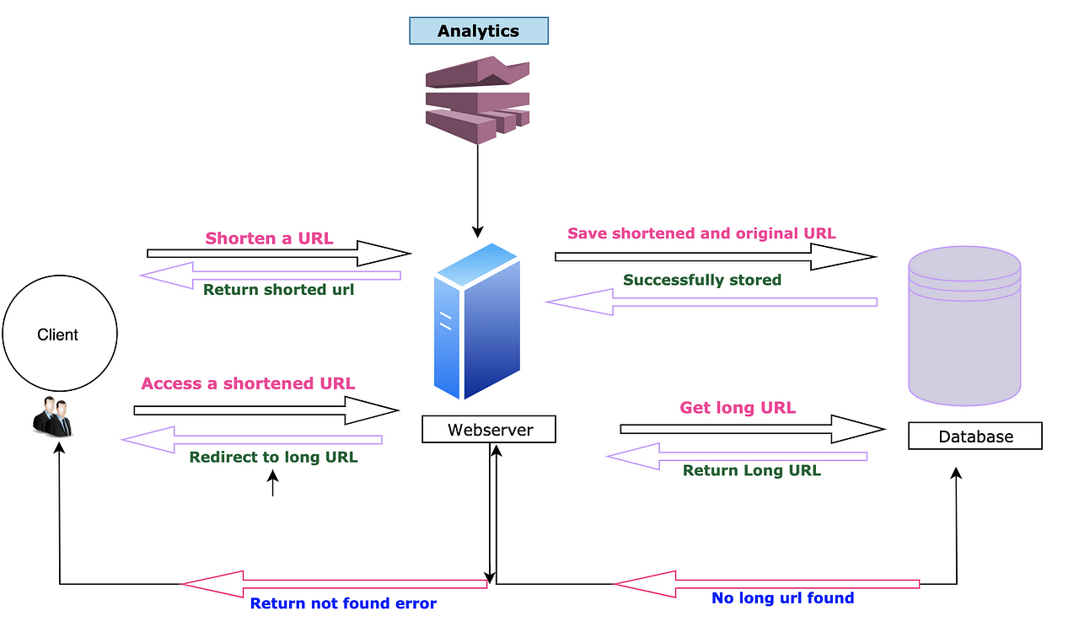

**Technologies and Software used**

Technologies Used here are:-

* Language:- Python
* OS:- Windows
* Technologies:- Flask, SQLAlchemy, Jinja, HTML, CSS, Bootstrap
* Hardware:- Laptop, Keyboard, Mouse

**Output**

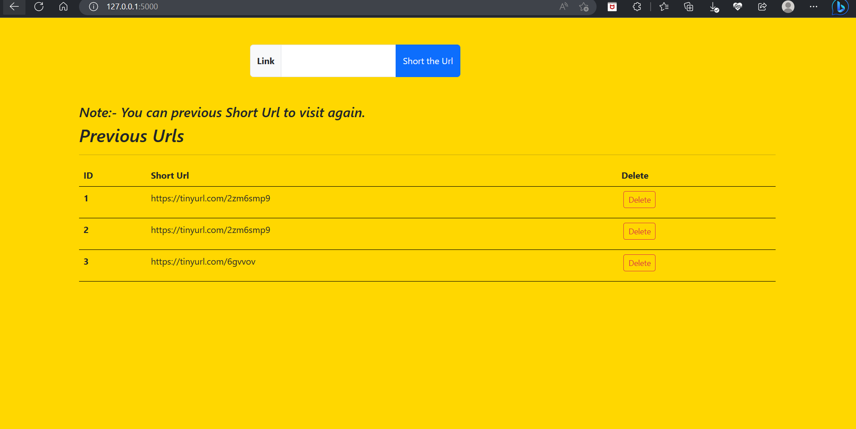

**Conclusion**

We have created a Flask application that allows users to enter a long URL and generate a shorter version. We can add more features to this application such as User Authentication, Shortened URLs Statistics, etc.These are the future plans of this project and can be implemented.

**References**

1. [Create a URL Shortener with Flask | by Ashutosh Krishna | Python in Plain English](https://python.plainenglish.io/create-a-url-shortener-with-flask-47d08c23a695)
2. [A URL Shortening Service by Using Flask Framework Based on Base-62 Algorithm | Request PDF (researchgate.net)](https://www.researchgate.net/publication/358619082_A_URL_Shortening_Service_by_Using_Flask_Framework_Based_on_Base-62_Algorithm)
3. [Bootstrap · The most popular HTML, CSS, and JS library in the world. (getbootstrap.com)](https://getbootstrap.com/)